How to turn in a Technology work order (ticket)
- Click on this link on your desktop. It will take you to your Eduphoria Login where you will login and follow these instructions.
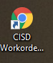
- Click on Help Desk
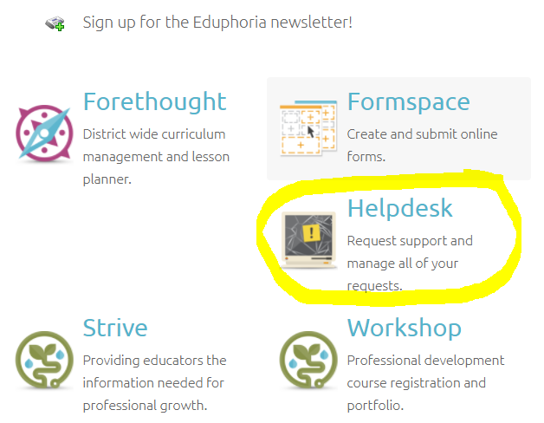
- Click on create a new request.
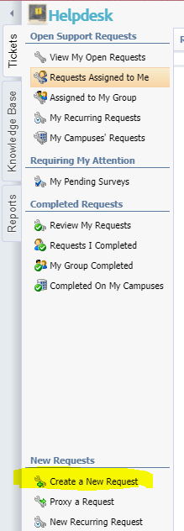

- Choose either Facility or Technology (whichever one you have the request for)

- You will then choose whatever category you need.
- You will then see another menu for most categories. You will choose whatever one you need in that menu.
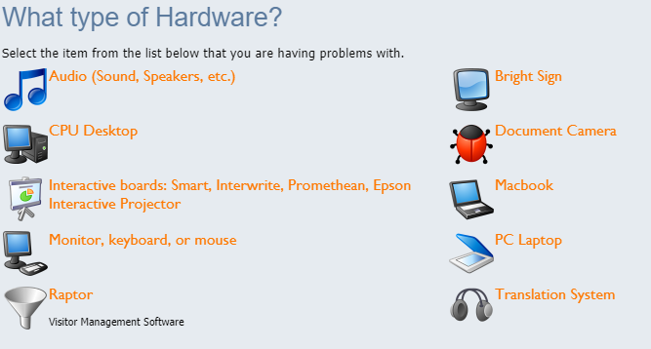
- You will then fill out the form. Make sure to put what campus, your room number, and a detailed description of what is wrong. If you do this then the tech will be able to help you much faster. In many cases, they may can even just call your room and walk you through what to do so that it gets fixed as fast as possible. You will click on the submit request button at the bottom when done and then the Finish button at the bottom of the next screen.
